блокировку страниц в памяти:
#include <windows.h>
#include <stdio.h>

int main() {
PVOID pMem = NULL;
int nPageSize = 4096;
int nPages = 400;
int nPageLock = 100;
long SizeCommit = 0;
int i;
char* Ptr;
int nMinPages = 200, nMaxPages = 500;
long dwMinimumWorkingSetSize = 0, dwMaximumWorkingSetSize = 0;
HANDLE hProcess;

hProcess = GetCurrentProcess();
dwMinimumWorkingSetSize = nMinPages * nPageSize;
dwMaximumWorkingSetSize = nMaxPages * nPageSize;

i = SetProcessWorkingSetSize(hProcess, dwMinimumWorkingSetSize, dwMaximumWorkingSetSize);
if (i == 0)
printf("SetProcessWorkingSetSize Error\n");
else
printf("Working set size successfully set.\n");

SizeCommit = nPages * nPageSize;
pMem = VirtualAlloc(0, SizeCommit, MEM_RESERVE | MEM_COMMIT, PAGE_READWRITE);
if (pMem == NULL)
printf("VirtualAlloc Error\n");
else
printf("Memory allocated successfully.\n");

Ptr = (char*)pMem;
for (i = 0; i < nPages; i++)
Ptr[i * nPageSize] = '0';

i = VirtualLock(pMem, nPageLock * nPageSize);
if (i == 0)
printf("VirtualLock Error\n");
else
printf("Memory locked successfully.\n");

for (i = 0; i < nPages; i++)
Ptr[i * nPageSize] = '0';

VirtualUnlock(pMem, nPageLock * nPageSize);
VirtualFree(pMem, 0, MEM_RELEASE);

printf("Memory freed successfully.\n");

return 0;
}

результат:
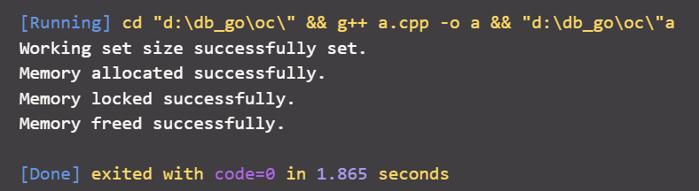

отложенное выделение памяти:
#include <windows.h>
#include <stdio.h>

int main() {
HANDLE hMapFile;
LPVOID lpMapAddress;
HANDLE hFile;
char* String;

hFile = CreateFile("MyFile.txt", GENERIC_READ | GENERIC_WRITE,
FILE_SHARE_READ | FILE_SHARE_WRITE, NULL, OPEN_ALWAYS,
FILE_ATTRIBUTE_NORMAL, NULL);

if (hFile == INVALID_HANDLE_VALUE) {
printf("Could not open file\n");
return 1;
}
else {
printf("File opened successfully\n");
}

hMapFile = CreateFileMapping(hFile, NULL, PAGE_WRITECOPY, 0, 0, "MyFileObject");
if (hMapFile == NULL) {
printf("Could not create file-mapping object.\n");
CloseHandle(hFile);
return 1;
}
else {
printf("File mapping object created successfully.\n");
}

lpMapAddress = MapViewOfFile(hMapFile, FILE_MAP_COPY, 0, 0, 0);
if (lpMapAddress == NULL) {
printf("Could not map view of file.\n");
CloseHandle(hMapFile);
CloseHandle(hFile);
return 1;
}
else {
printf("File mapped successfully.\n");
}

String = (char*)lpMapAddress;

sprintf(String, "Hello, world");
printf("%s\n", String);

if (!UnmapViewOfFile(lpMapAddress)) {
printf("Could not unmap view of file.\n");
}

CloseHandle(hMapFile);
CloseHandle(hFile);

return 0;
}

результат:
